**Assignment Two: Graph Stores**

**\*\*USE NEO4J FOR THIS ASSIGNMENT** (**download at** <https://neo4j.com/>

**OR use the online console** <http://console.neo4j.org/>)

**PART I: PLANNING YOUR GRAPH STORE (WRITE DOWN YOUR RESUTS FOR EACH**

**QUESTION 3-7)**

1. Go to The Movie Database Website <https://www.themoviedb.org/?language=en-US>



1. Use the search feature to search for Fantastic Beasts The Crimes of Grindelwald

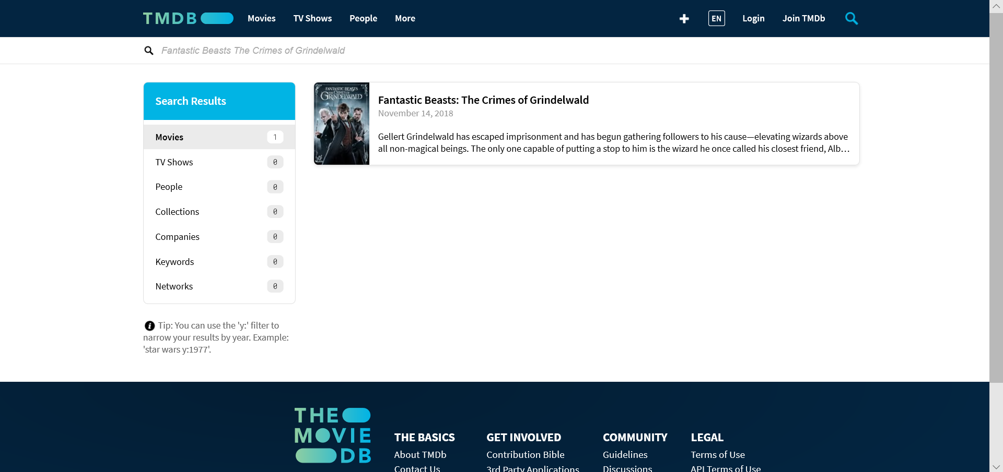

1. Write down the movie name

FANTASTIC BEASTS: The Crimes of Grindelwald (2018)

1. Click on more info



1. Write down the director’s name

David Yates

1. Write down the following two actors
   1. Eddie Redmayne b. Katherine Waterston

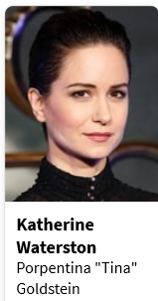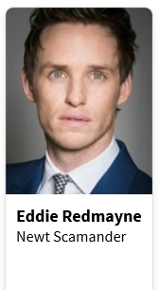

1. Click each of the actors listed in number 6 above: Eddie Redmayne and Katherine Waterston

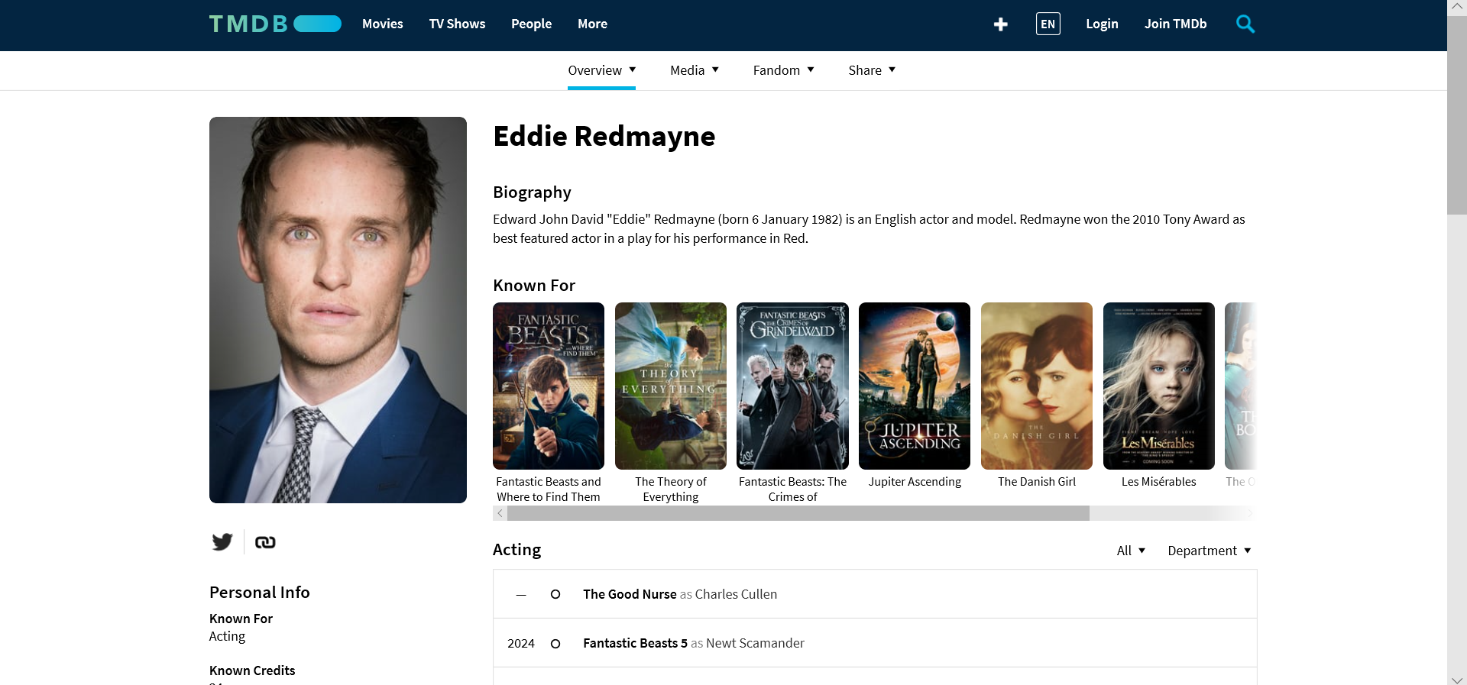

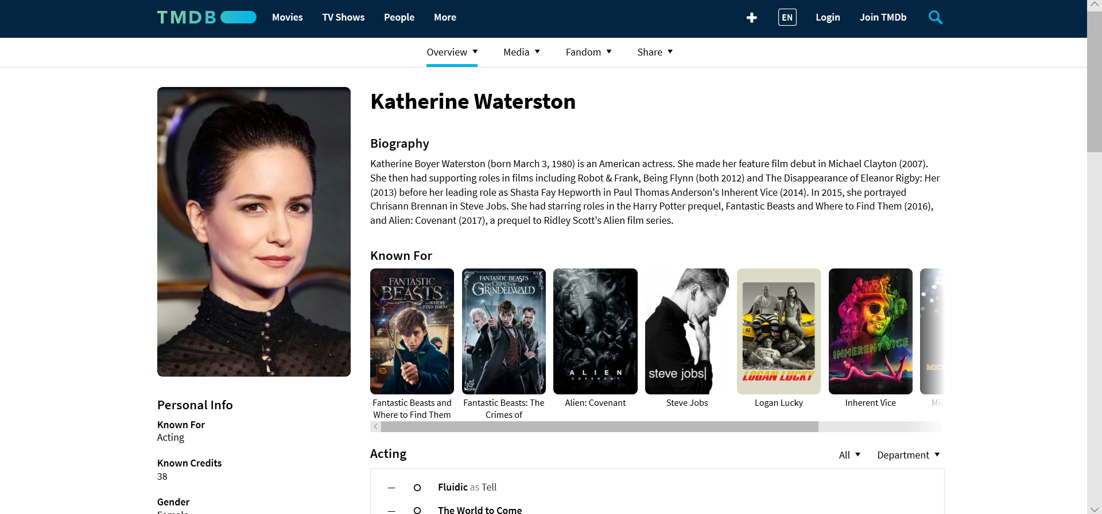

1. For each of the actors above list the first three movies under the category “Known for.” Write down your results.
   1. Eddie Redmayne:

* Fantastic Beasts and Where to Find Them
* The Theory of Everything
* Fantastic Beasts: The Crimes of Grindelwald
  1. Katherine Waterston:
* Fantastic Beasts and Where to Find Them
* Fantastic Beasts: The Crimes of Grindelwald
* Alien: Covenant

1. For each of the three movies,
   1. list the director. Write down your results.

|  |  |
| --- | --- |
| Movie name: | Director: |
| Fantastic Beasts and Where to Find Them | David Yates |
| The Theory of Everything | James Marsh |
| Fantastic Beasts: The Crimes of Grindelwald | David Yates |
| Fantastic Beasts and Where to Find Them | David Yates |
| Fantastic Beasts: The Crimes of Grindelwald | David Yates |
| Alien: Covenant | Ridley Scott |

* 1. list two additional actors that played alongside the actor in 6 above. Write down your results.
* Eddie Redmayne:
* Johnny Depp
* Colin Farrell
* Katherine Waterston:
* Michael Fassbender
* Alison Sudol

**PART II: CODING (SCREEN SHOTS OF ALL CODE AND RESULTS FOR EACH QUESTION 8-11)**

**For the following include all the movies, actors and directors you identified in 3-8 above, including the movie Fantastic Beasts: The Crimes of Grindelwald.**

**NOTE: Code enough of information to identify the object being described, so for example for the actor Katherine Waterston, if there are no other actors called Katherine in your data, then just use her first name when you are coding. The same holds true for movie names, code as much as makes sense. If names actor names, director names or movie names are too large, shorten them.**

1. Create nodes for the following:
   1. 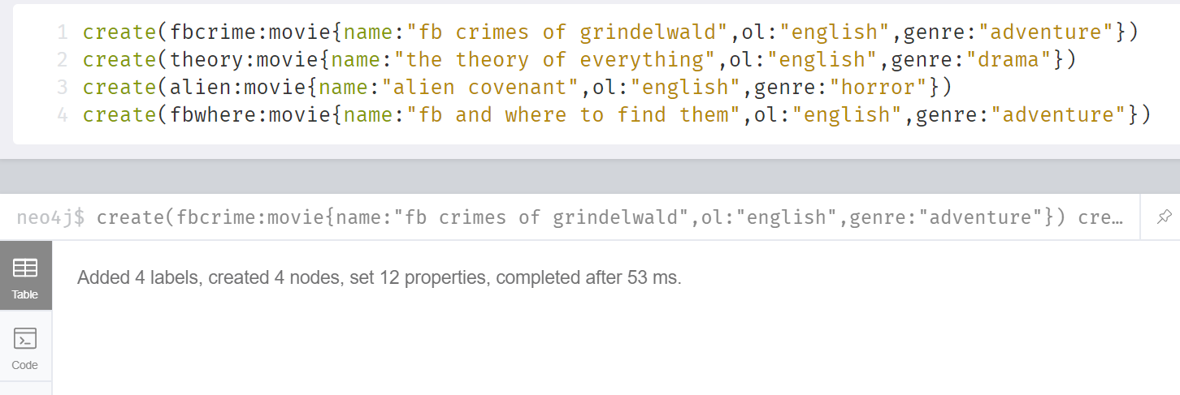the movies – properties: original language, genre (pick first genre listed)

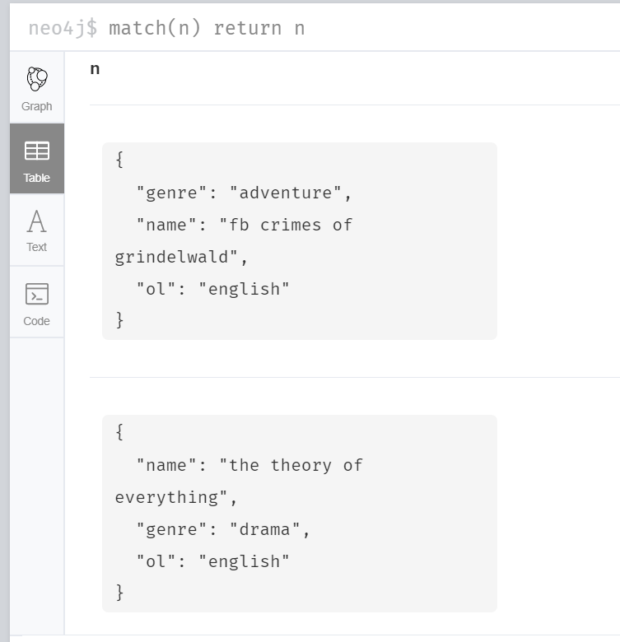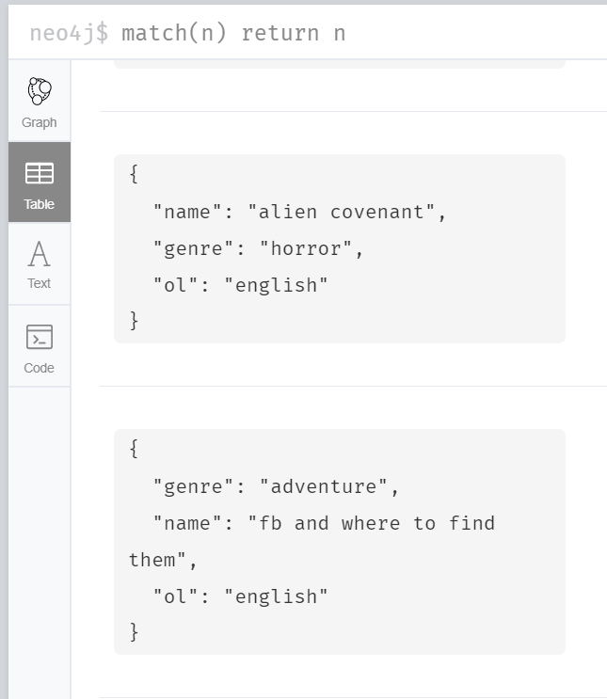

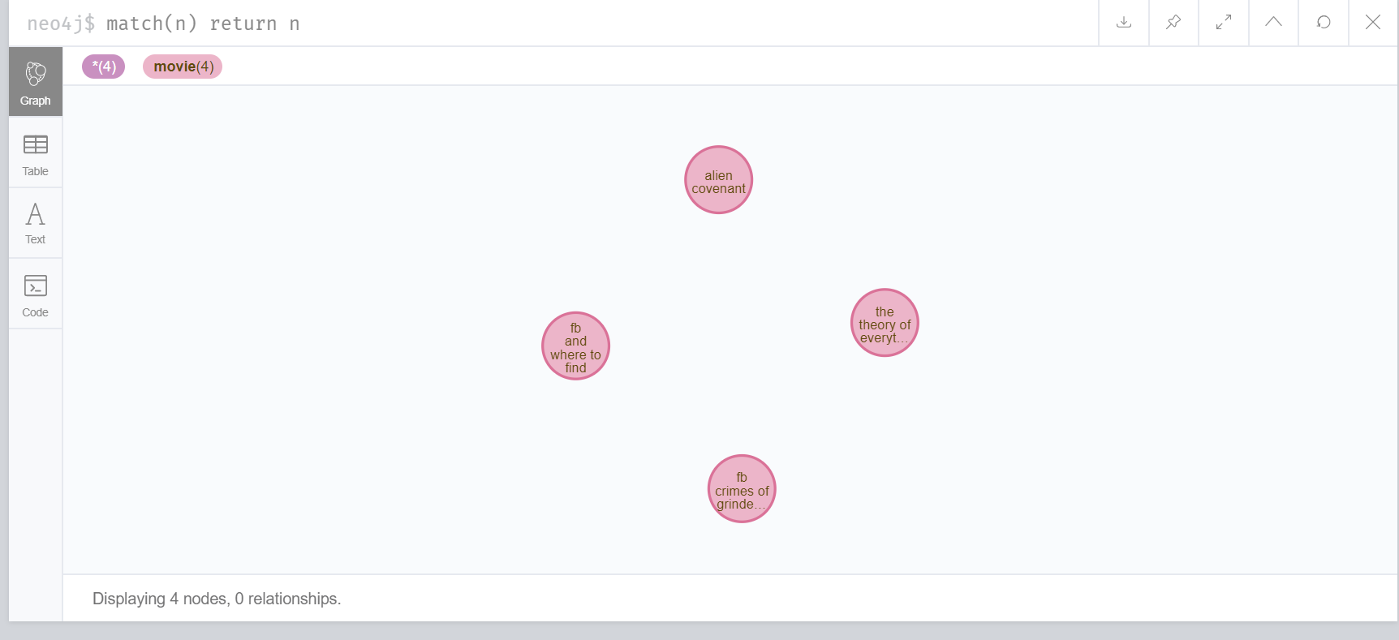

* 1. the actors – properties: name, place of birth(country), year of birth

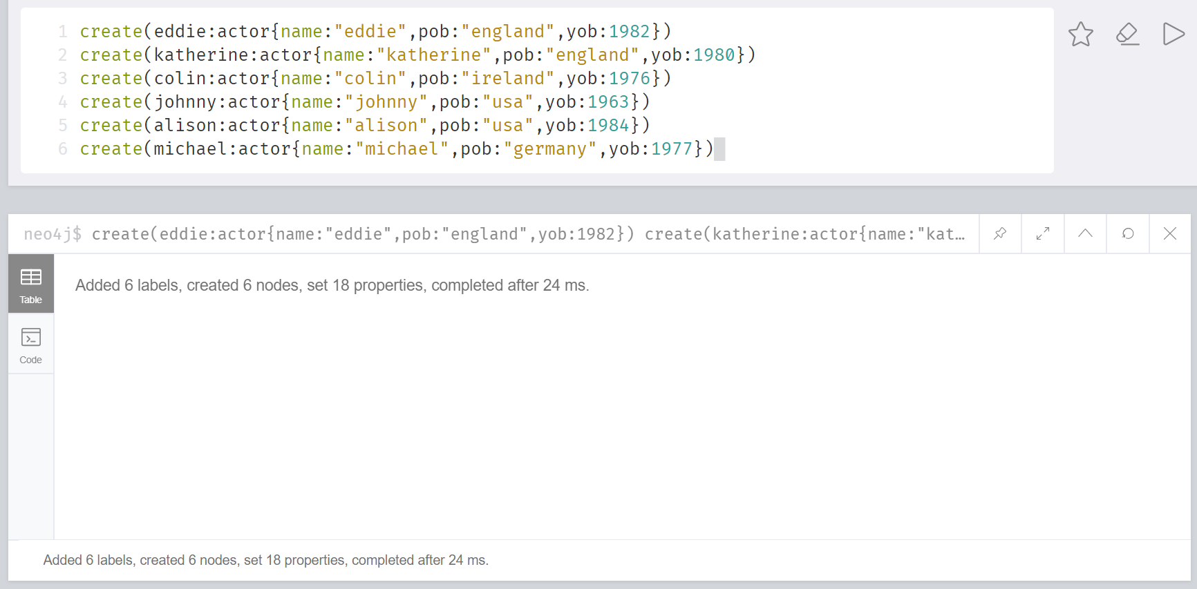

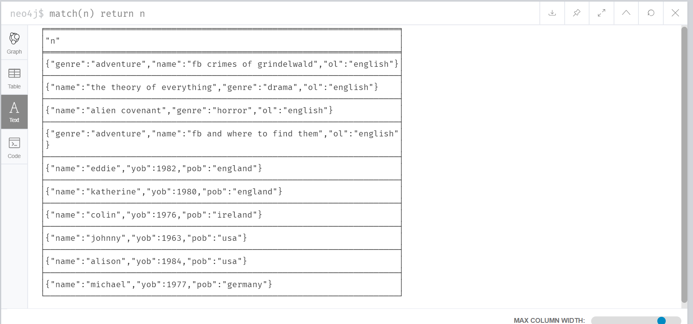

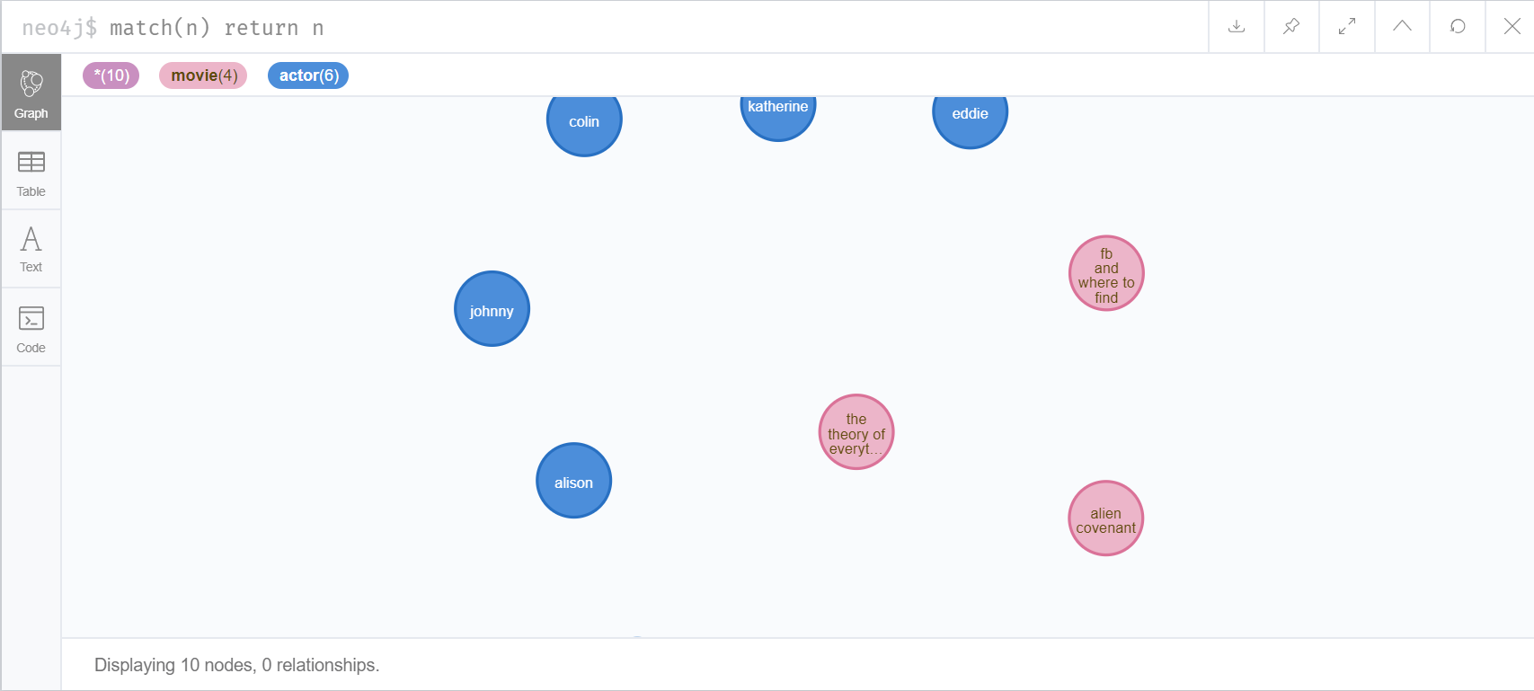

* 1. the directors - properties: name, place of birth (country), year of birth

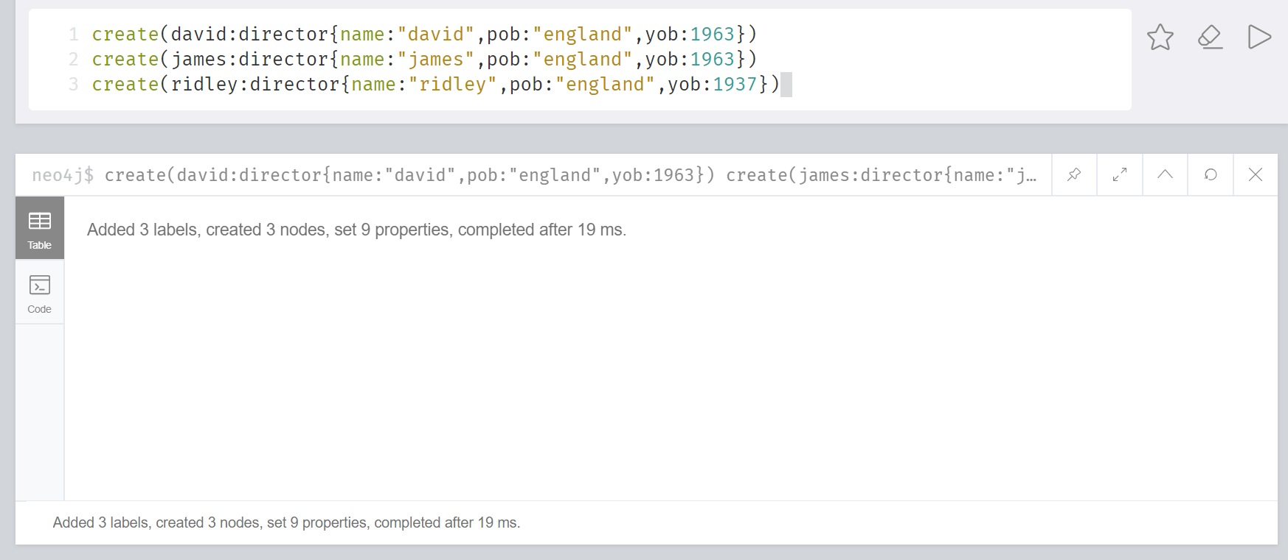

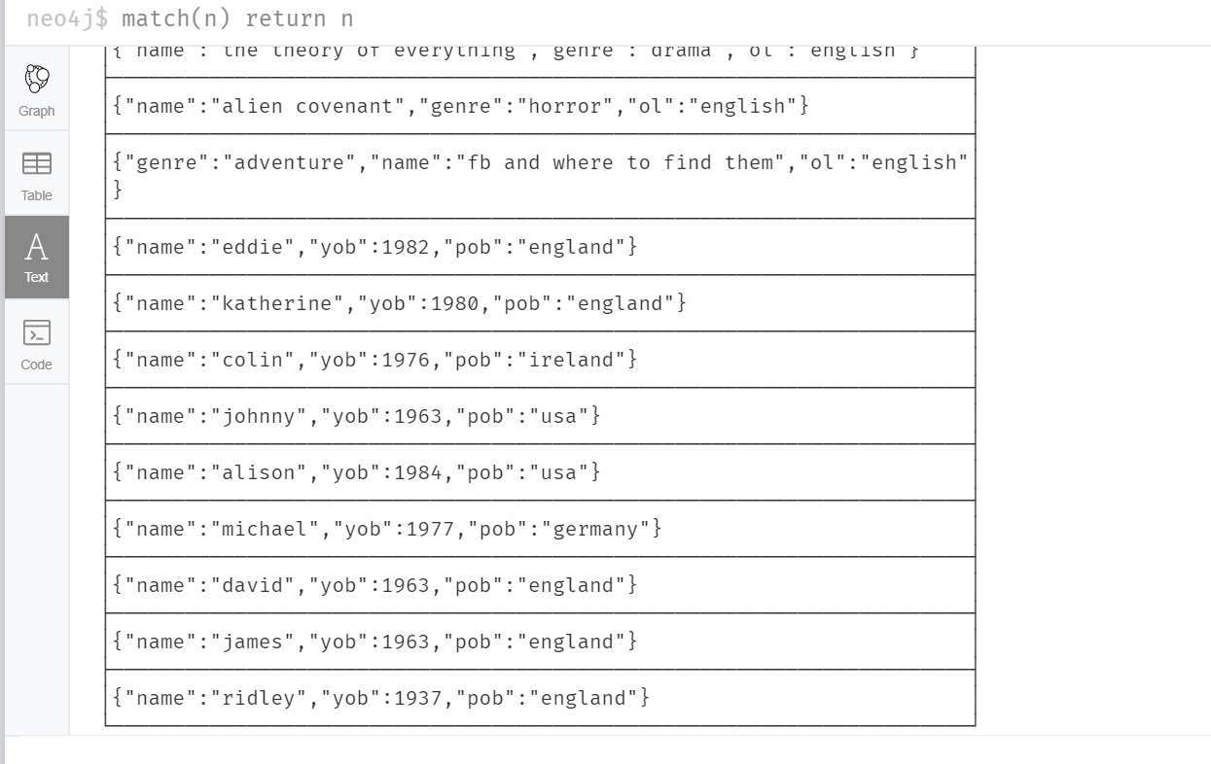

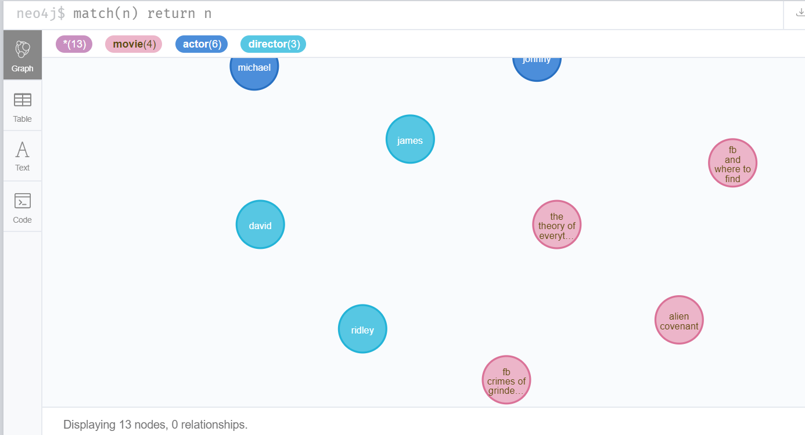

1. Create the relationships between:
   1. the movies and the actors,
      1. relationship: actor to movie – “acted in”

I tried to insert my code together but I got this:

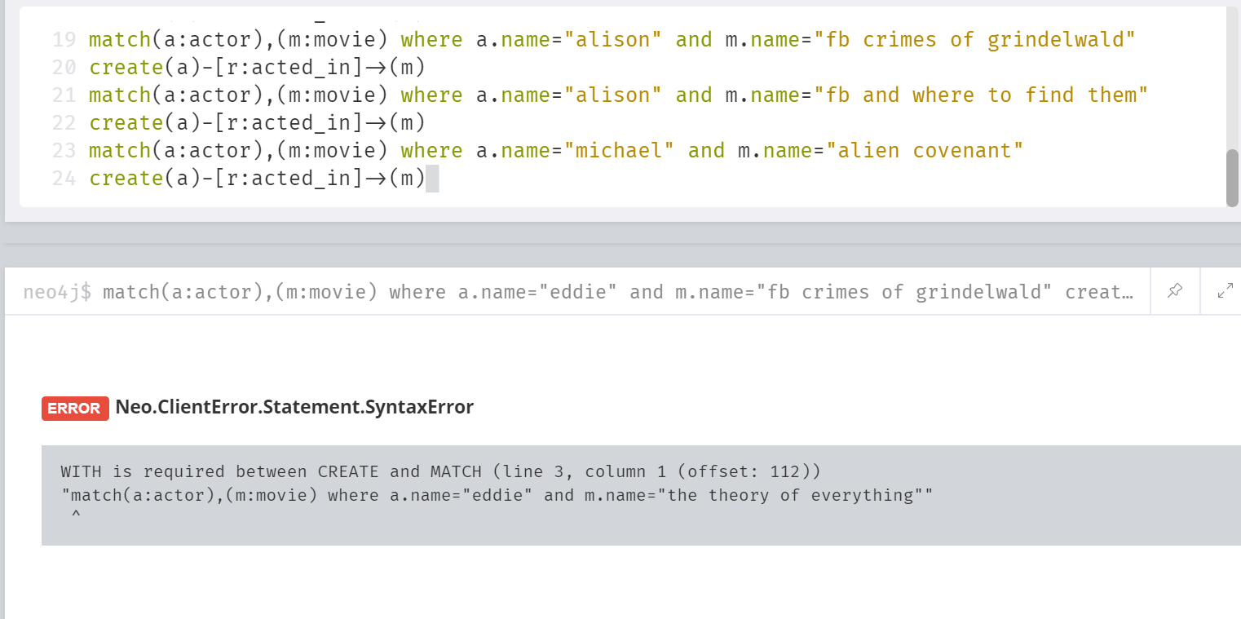

So instead, I did it one by one like this:

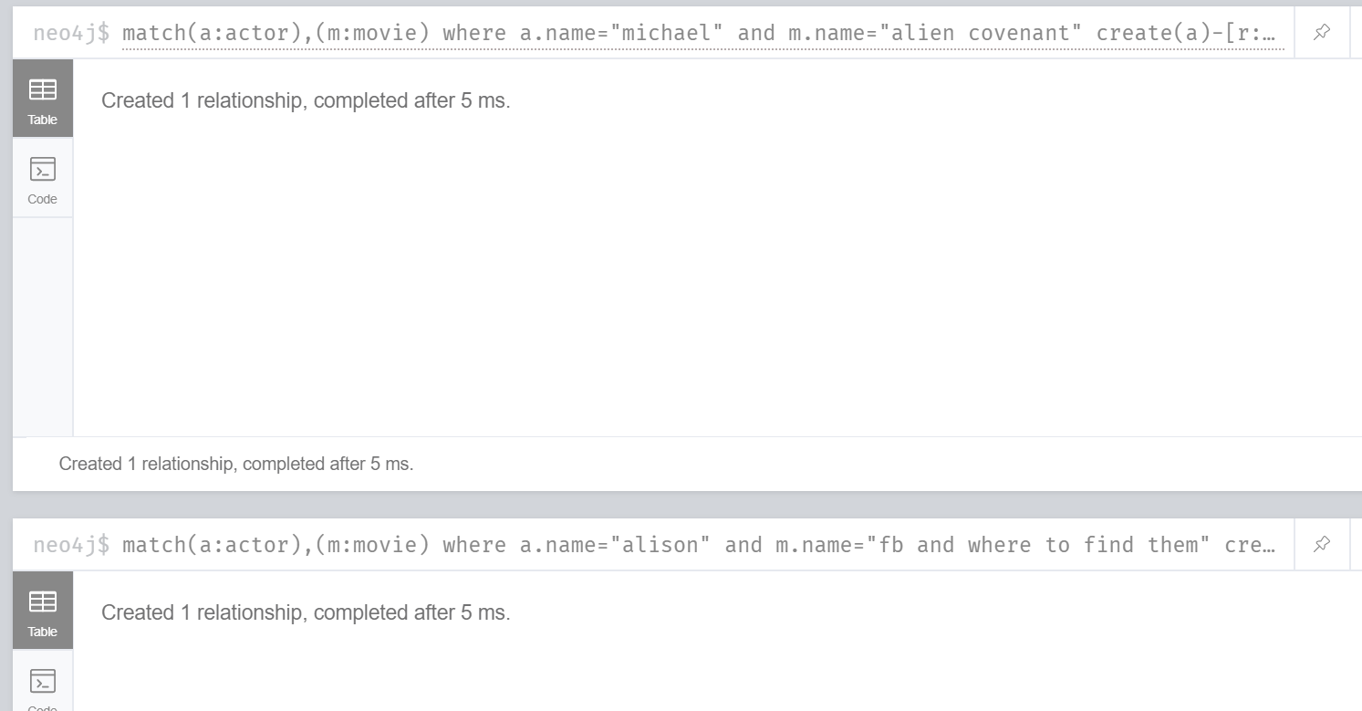

This is the all the code I inserted:

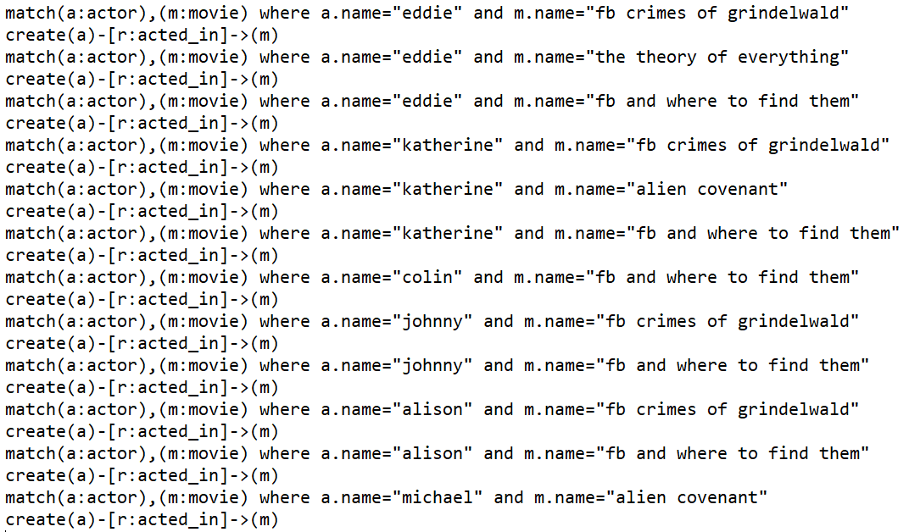

Result:

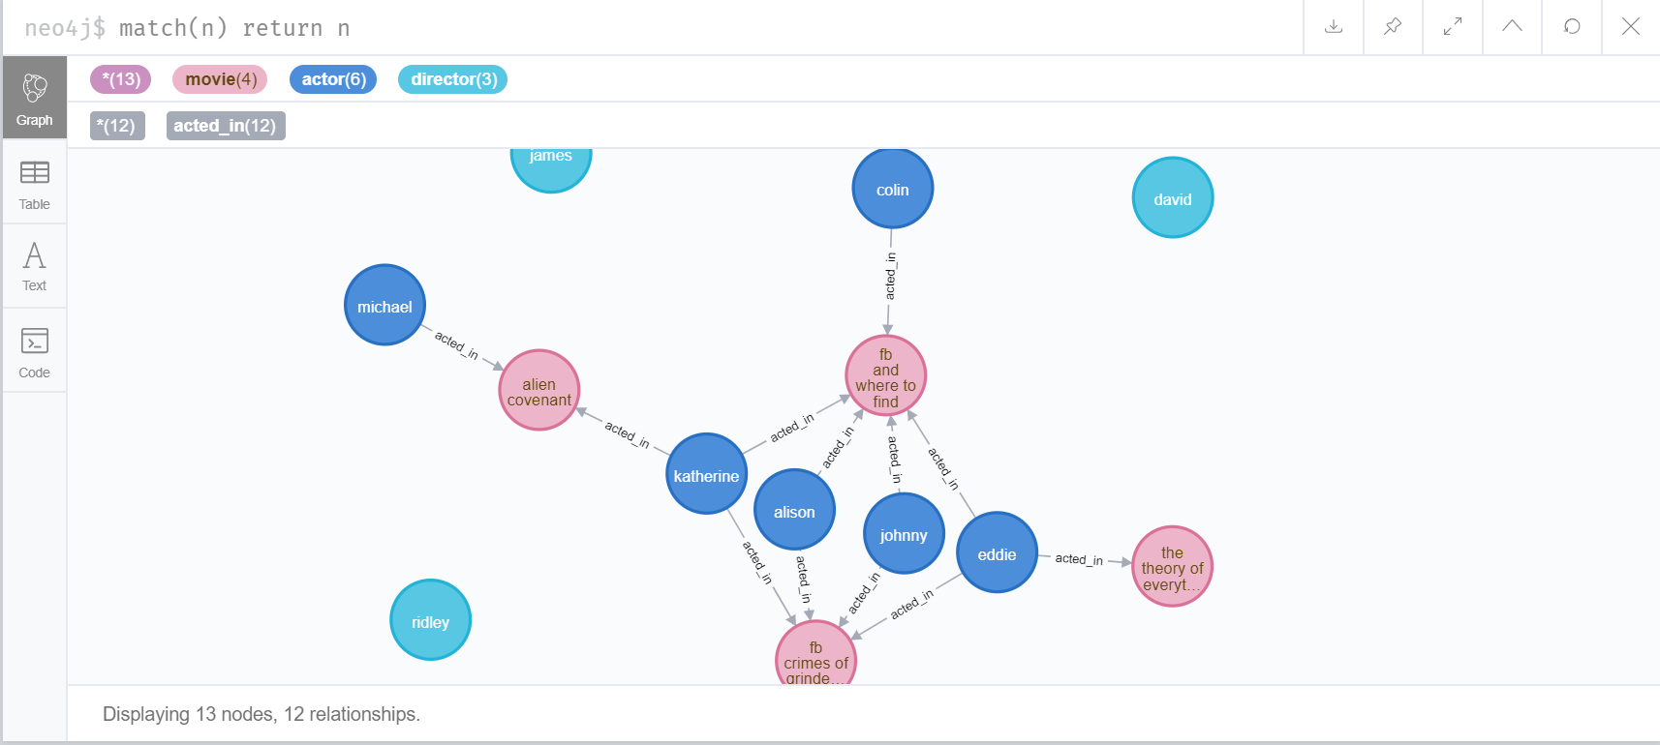

* + 1. relationship: movie to actor – “has actor”

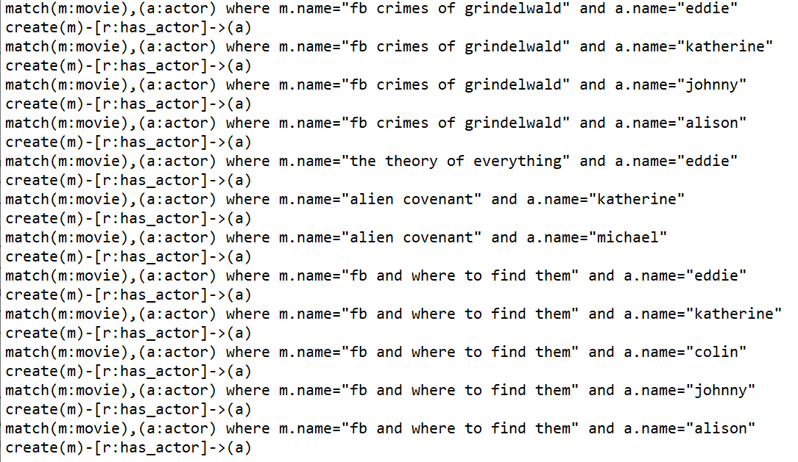

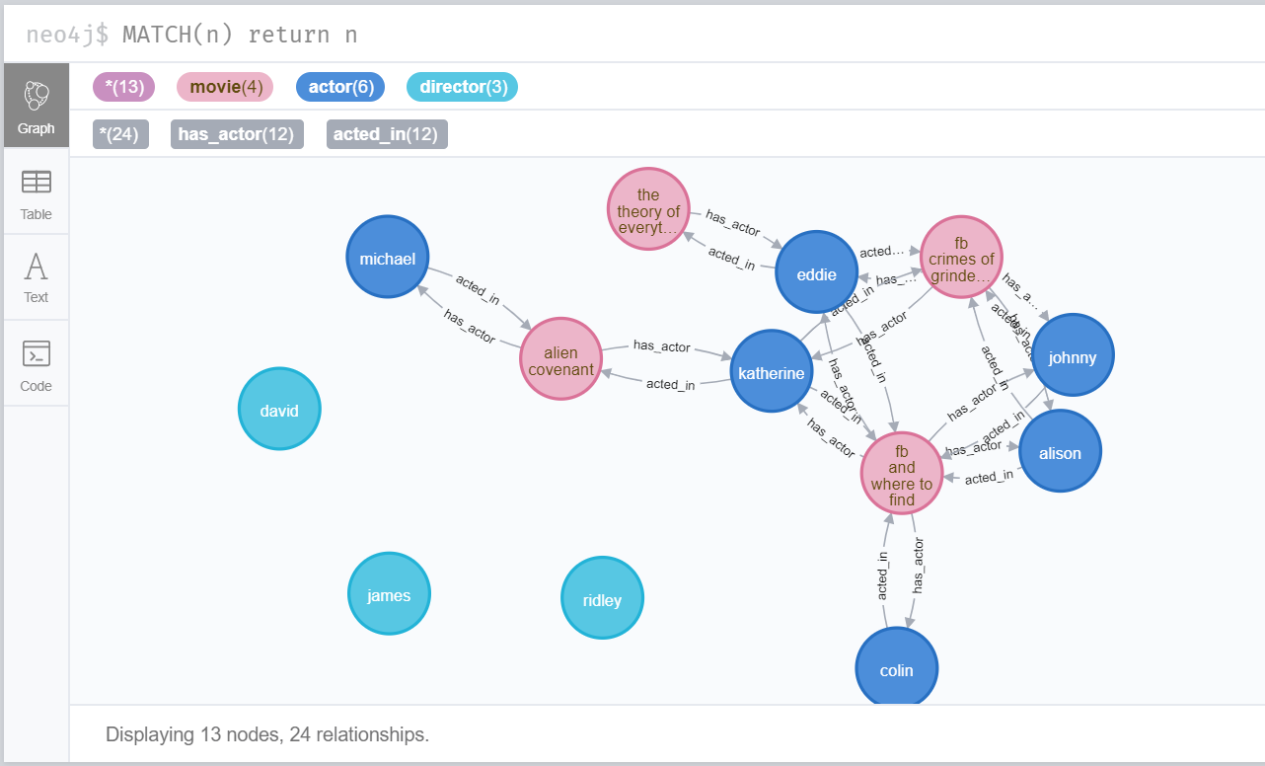

* 1. the actors and the directors,
     1. relationship: actor to director – “worked under”

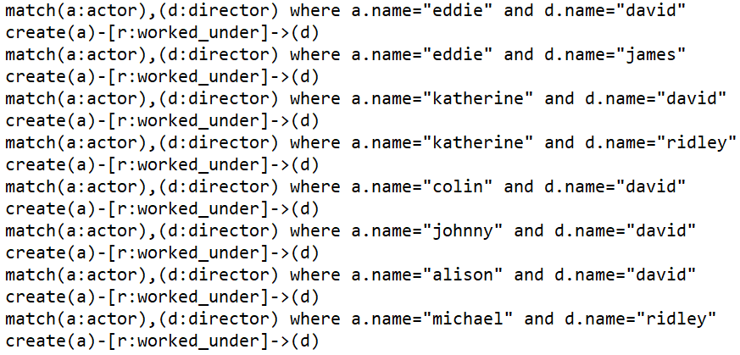

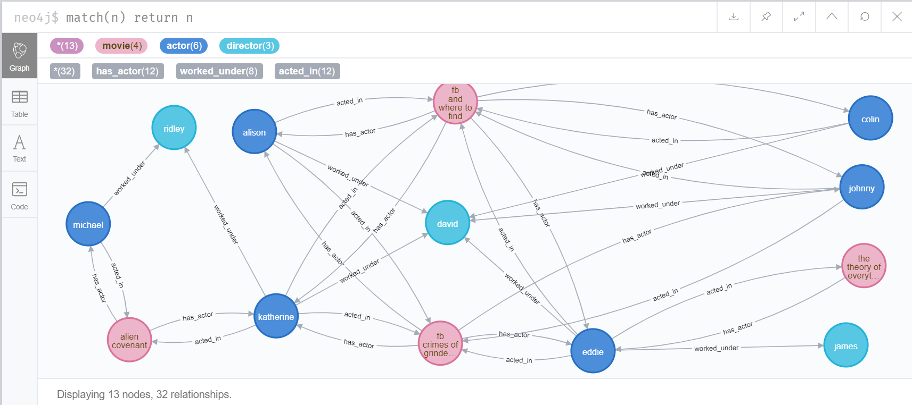

* + 1. relationship: director to actor – “directed actor”

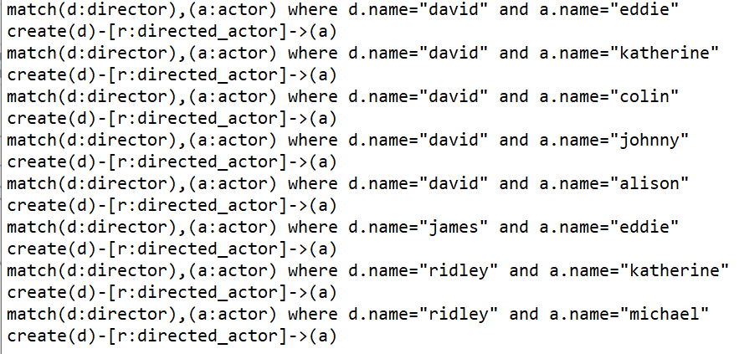

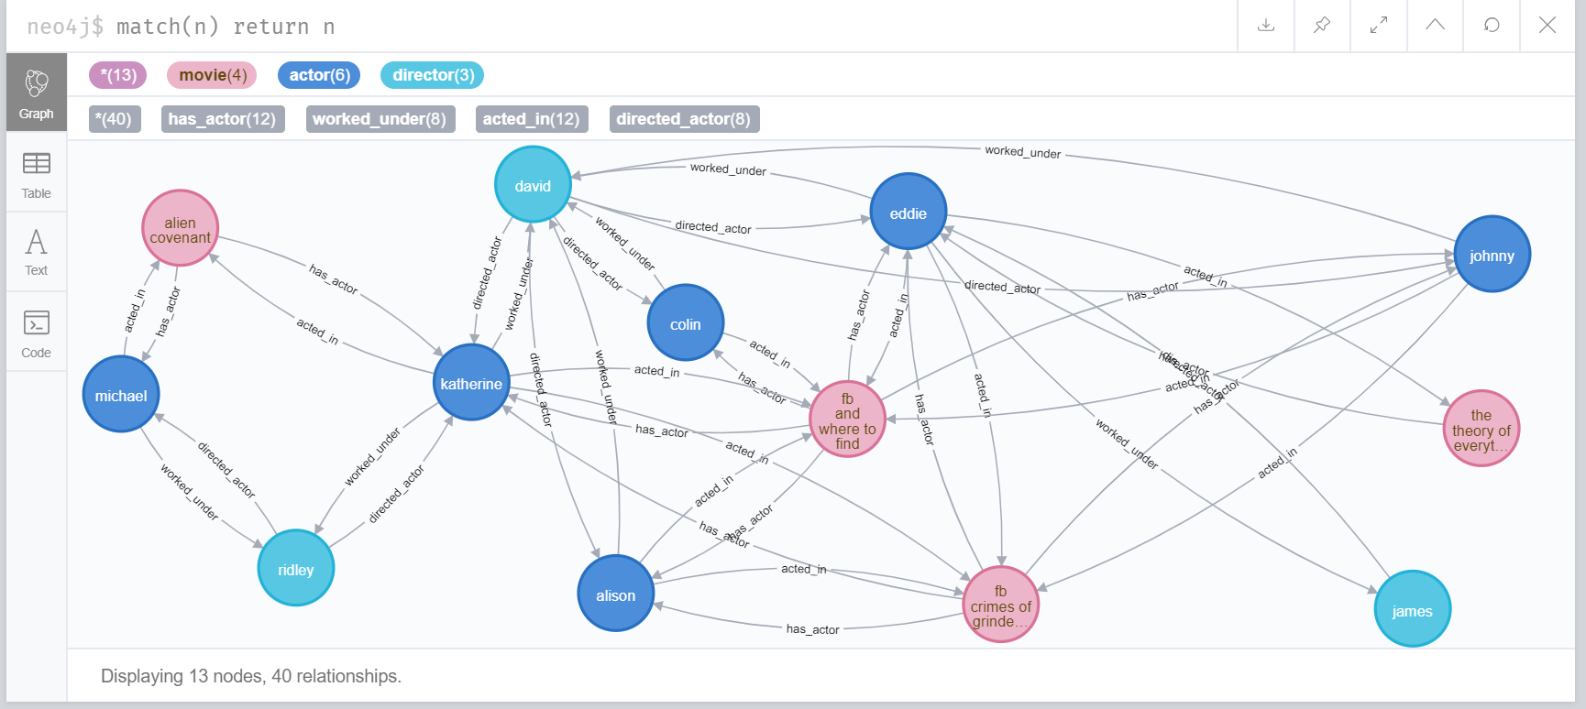

* 1. the directors and the movies
     1. relationship: director to movie – “directed”

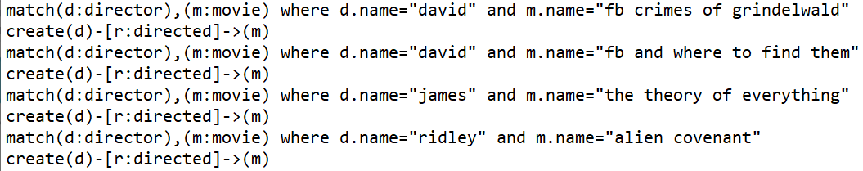

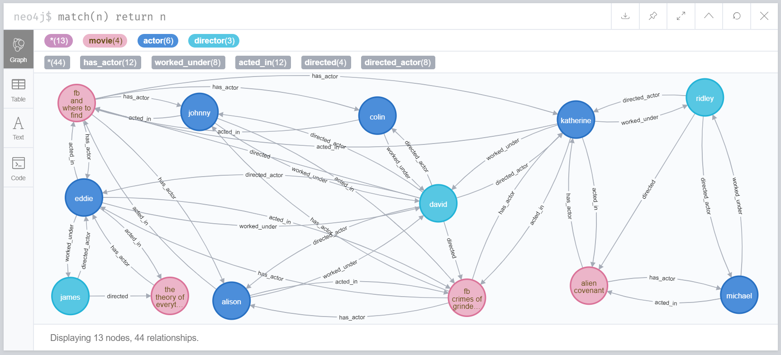

* + 1. relationship: movie to director – “was directed by”

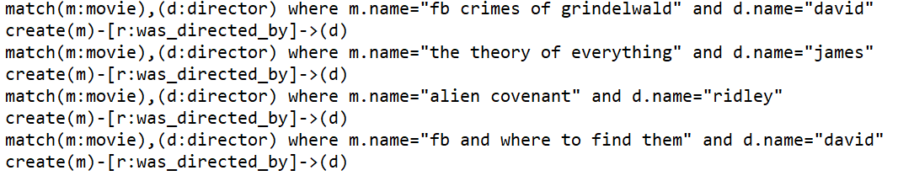

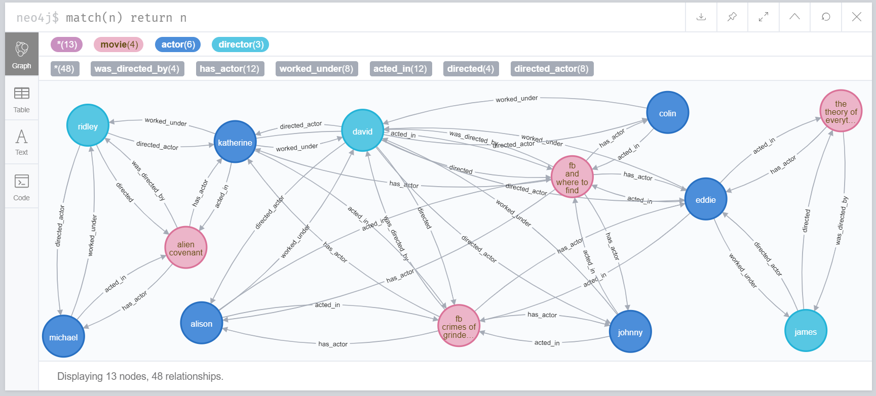

* 1. the actors and the other actors in the same movie and/or in other movies in which the actor in question 5 has starred
     1. relationship: actor to actor – “worked with”

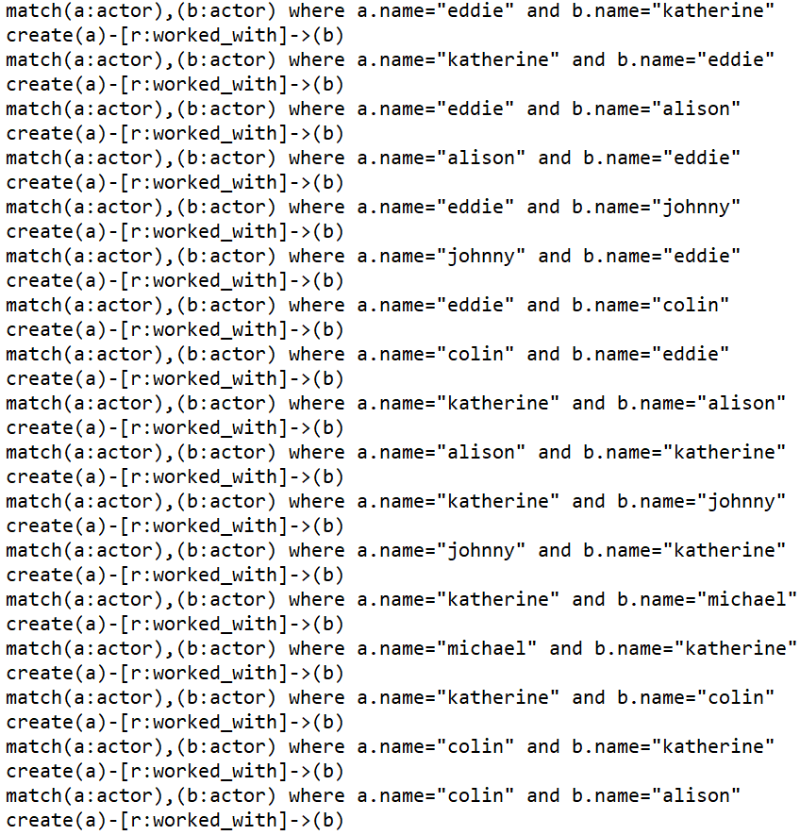

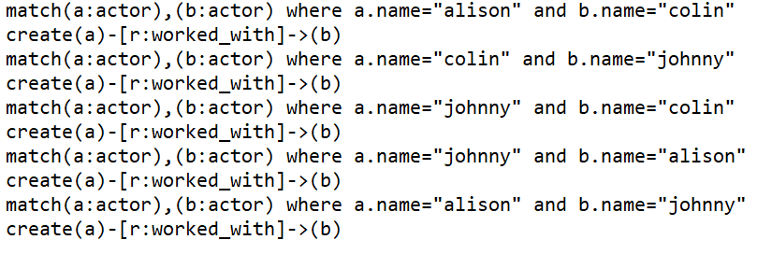

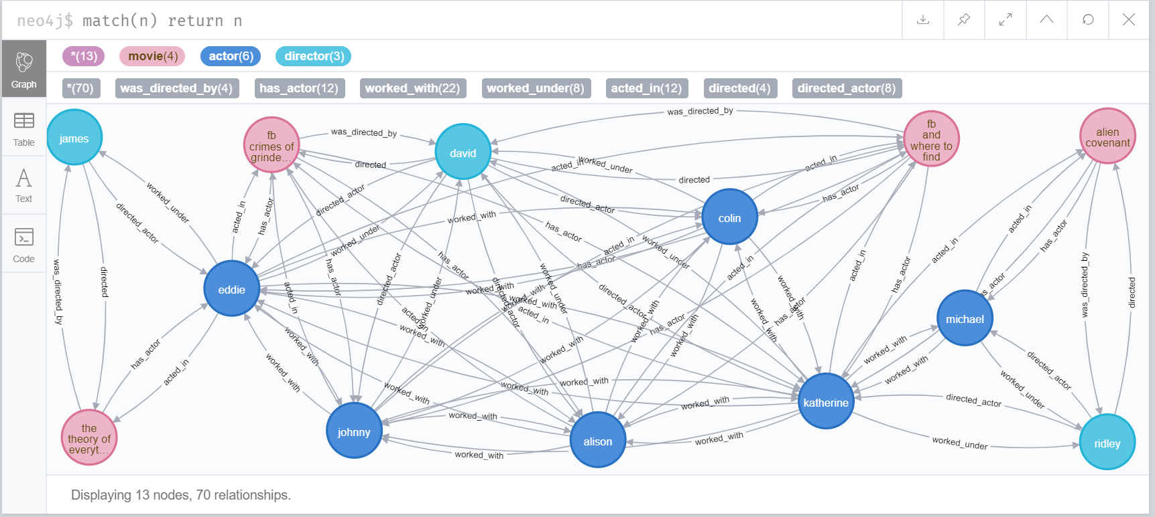

1. Use the Neo4j command to find out:
   1. In what movies have the actors in question 6 acted

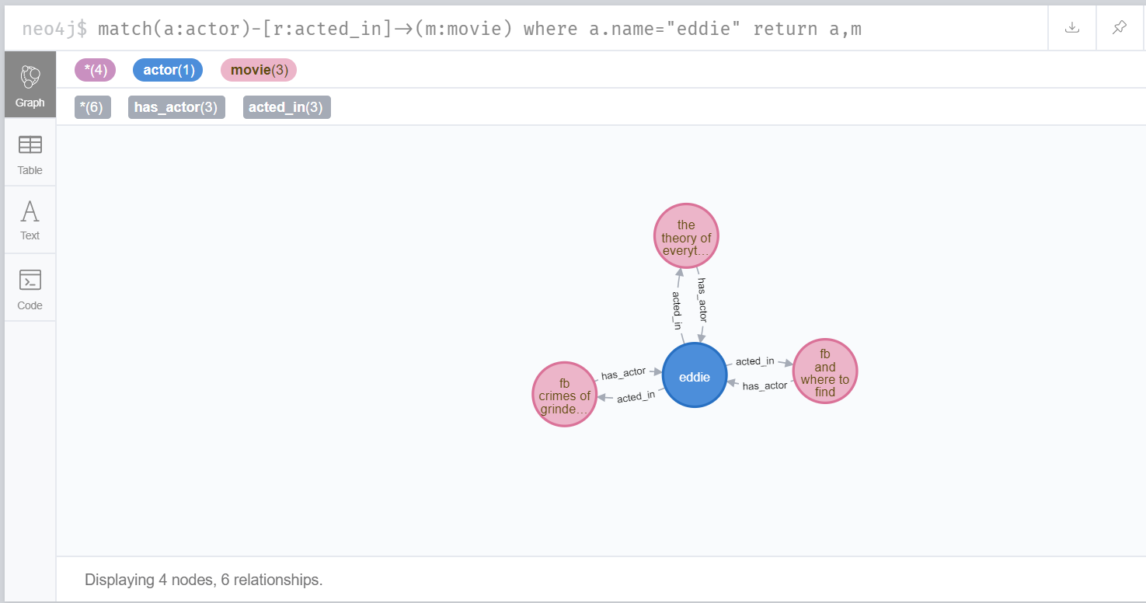

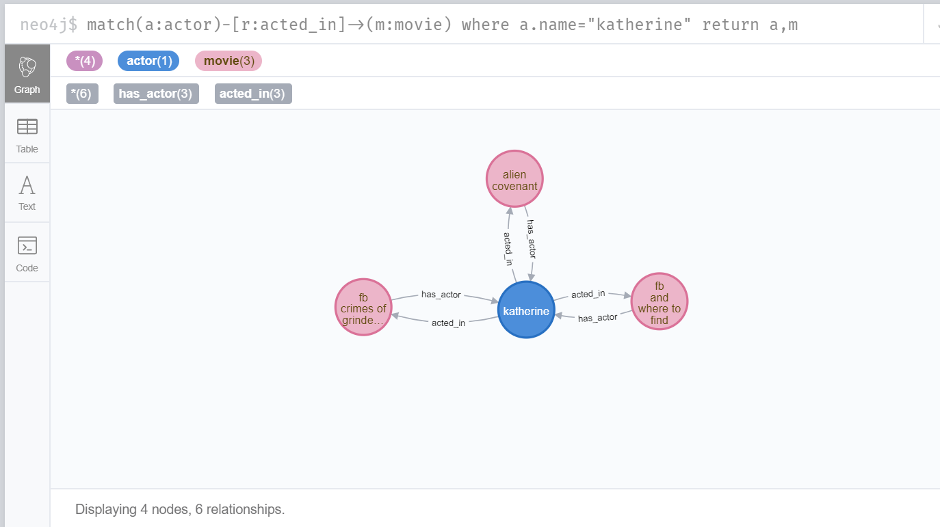

* 1. With which actors have the actors in question 6 worked

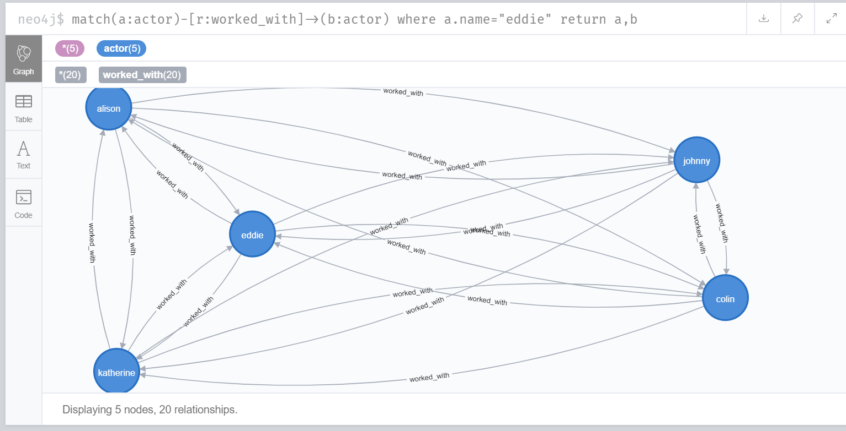

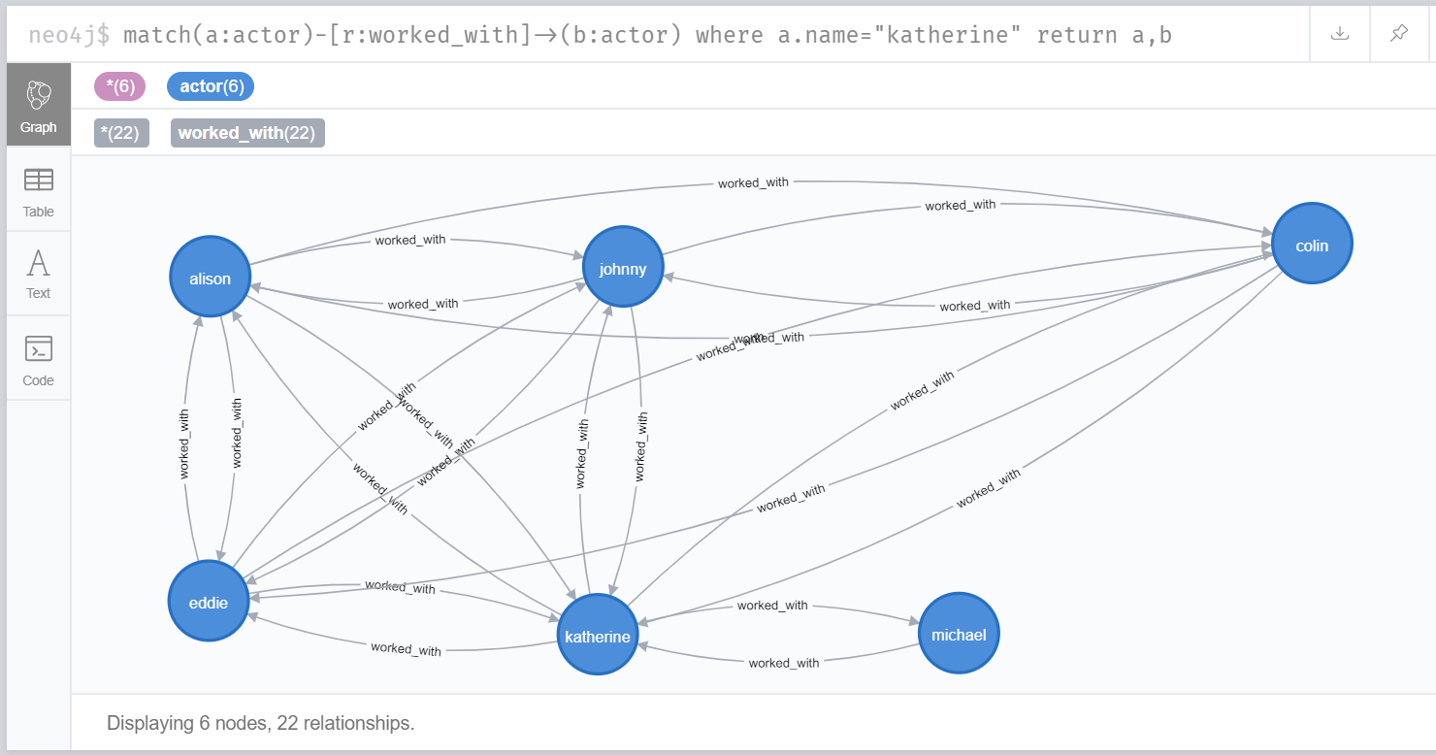

* 1. Under which directors have the actors in question 6 worked under

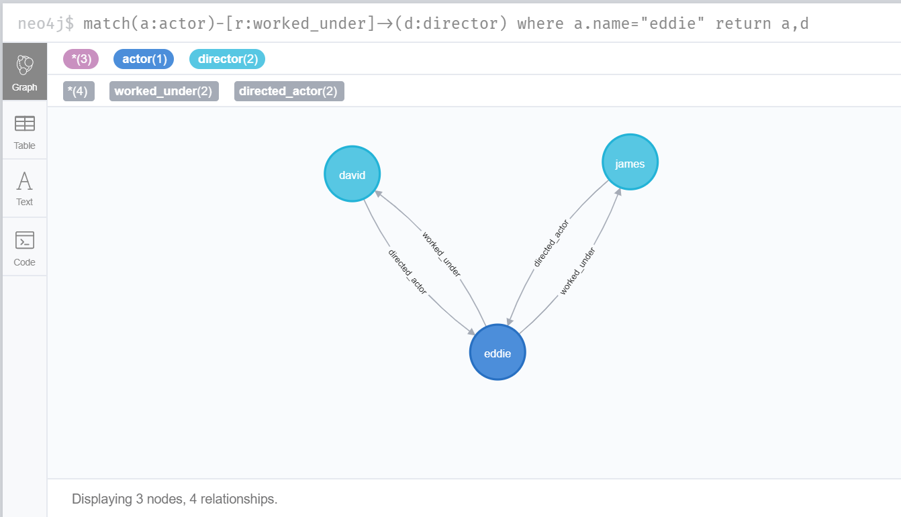

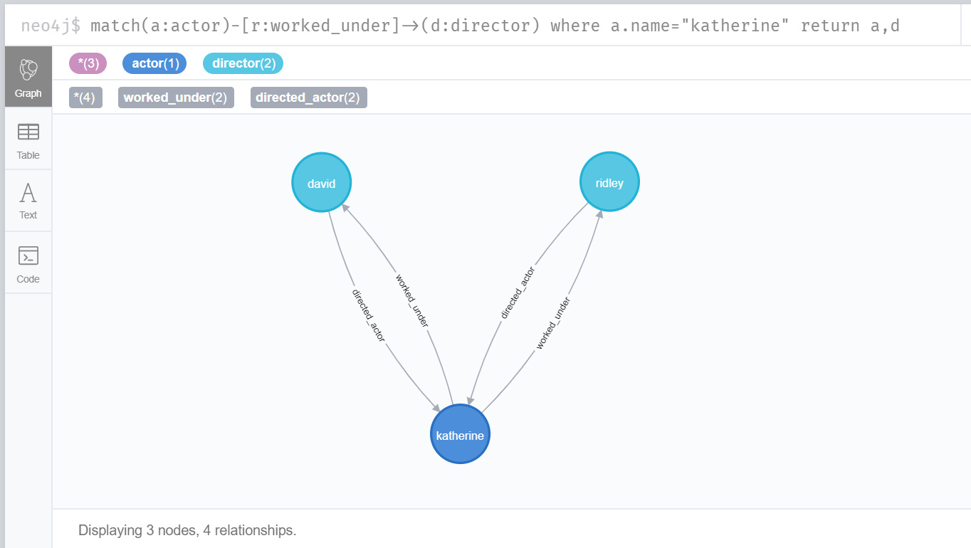

* 1. Which actors are born in England

